Name: *Ahmed Hassanin Hassan Eldakhakhni*

Group : *1*

Section : *3*

B.N : *7*

Date : *4-6-2021*

Topic : *Artificial Intelligence*

Application Brief :

*Artificial Intelligence enhances the speed, precision and effectiveness of human efforts. In financial institutions, AI techniques can be used to identify which transactions are likely to be fraudulent, adopt fast and accurate credit scoring, as well as automate manually intense data management tasks.*

# Screenshots:

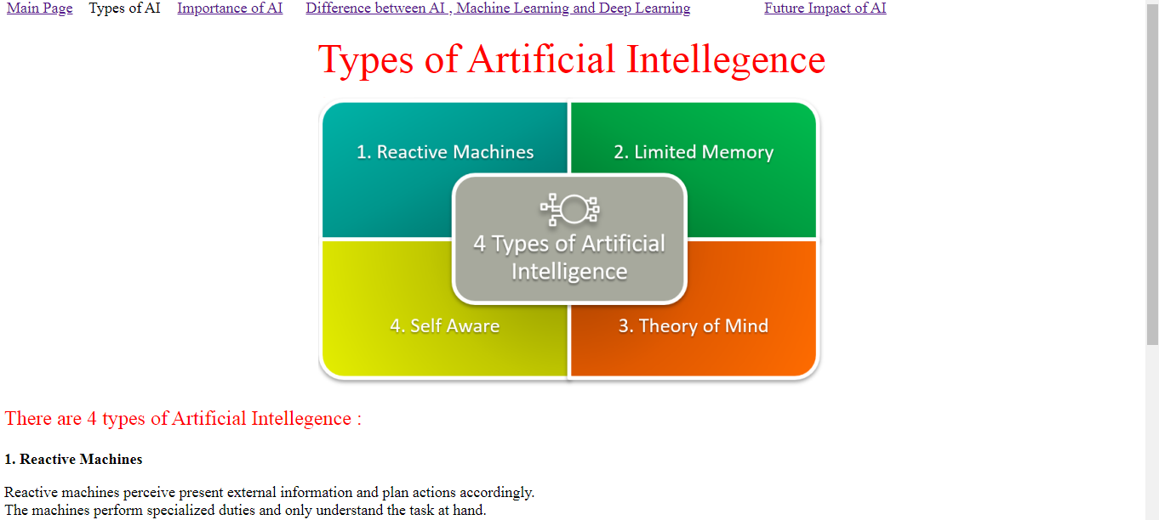

# Source Code :

